Shape Up! 18 Use JavaScript and jQuery to calculate BMI and add image swaps

In this exercise, you’ll create a page that uses JavaScript to calculate BMI. In addition, you’ll create a diet page that uses jQuery for image swaps with ideas for replacing unhealthy foods with healthy foods.

Specifications for the BMI calculation

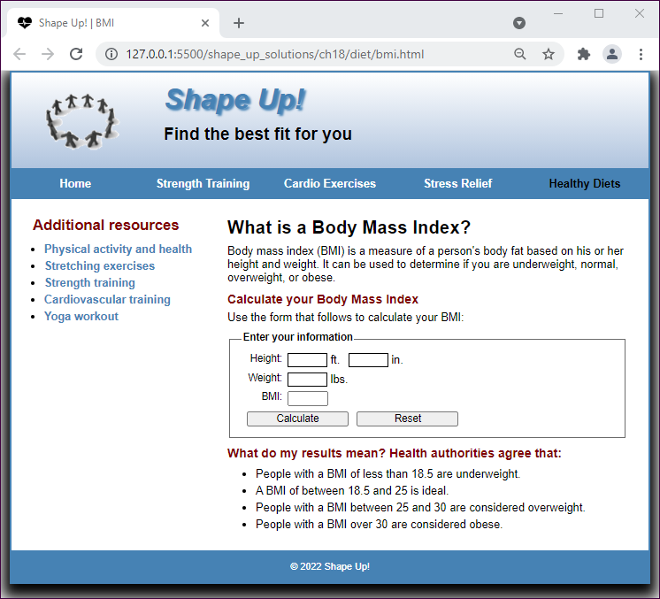

* Open the bmi.html file in the diet folder. This file contains the basic content for an “under construction” page.
* Delete the two headings in the main element. Then, copy the link elements for the favicon and style sheets, as well as the code for the header, footer, navigation menu, and sidebar, from the index.html page for exercise 7, and add a section element before the sidebar.
* Modify the navigation menu so it indicates that one of the healthy diets pages is the current page, and modify the links in the menu as necessary.
* Create a new style sheet named bmi.css, and copy the styles you need from the main.css file to this style sheet. Then, modify the link element for the style sheet in the bmi.html file so it points to the correct style sheet.
* Add the content of the bmi.txt file in the text folder to the section. Then, add the form and controls shown above. Note that because JavaScript will be used to process the information that’s entered, it’s not necessary to include action or method attributes. Also note that the value in the BMI text box shouldn’t be able to be changed.
* Add a script element to the bmi page that includes the bmi.js file in the js folder.
* Open the bmi.js file and review its code. Use this code to determine the required ids of the four text boxes and the Calculate button in the form on the bmi page. Then, set the ids of these controls. In addition, set the for attributes of the labels associated with the text boxes.

Specifications for the diet page

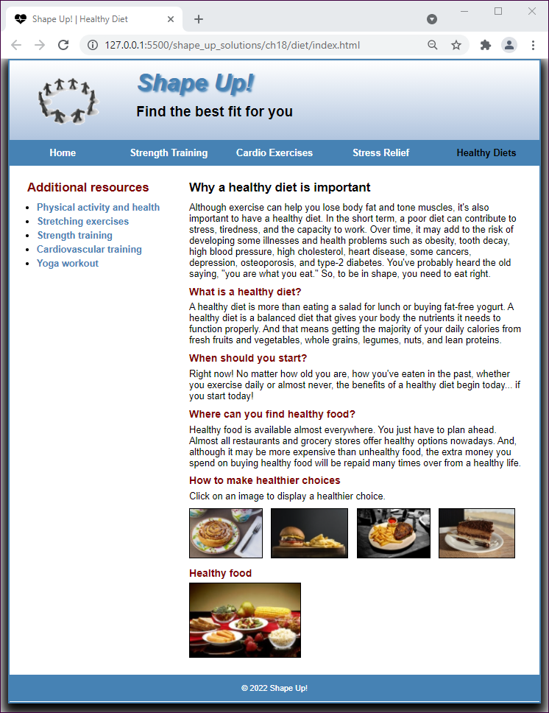

* Open the index.html page in the diet folder. This file contains the basic content for an “under construction” page.
* Delete the two headings in the main element. Then, copy the code for the header, footer, navigation menu, and sidebar from the index.html page for exercise 7, and add a section element before the sidebar.
* Modify the navigation menu so it indicates that one of the healthy diets pages is the current page, and modify the links in the menu as necessary.
* Create a new style sheet named diet.css, and copy the styles you need from the main.css file to this style sheet. Then, modify the link element for the style sheet in the index.html file so it points to the correct style sheet.
* Add the content of the diet.txt file in the text folder to the section. Then, add the script elements that are needed to create the image swaps. You’ll find the image_swap.js file in the js folder, and you can get the jQuery library from the jQuery Content Delivery Network.
* Add the heading and text, followed by the image swaps, to the bottom of the section. You’ll find the image files you need in the images/foods folder.
* Add any other formatting as necessary so the page looks as shown above.